**The Passing of Bro. Michael Winchester**

**October 19, 1964 – November 15, 2016**

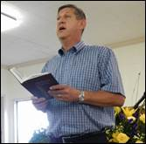

     - A good man died on Tuesday.  A decent, loving and honorable husband, father, son, grandson, friend and deacon in his Church was blessed to open his eyes in glory, to behold the face of his Savior.  As I write this, I grieve for Sis. Julie and the Winchester family, but I confess I am still overcome with anger, at this sick and senseless tragedy.  May God forgive me for my flesh and help me to give Him the praise, for He is still in control.  If it were not for His grace and providential care over us – every day would be as filled with evil as Tuesday was.  Every moment we live, is but by the grace of God.  As Pilgrim’s and Stranger’s in this land, we are surrounded by evil – much of which we never even notice, because the Lord intervenes and blesses us in ways that we don’t even know.  It is through His grace, we can rejoice in the knowledge that no matter what happens in this world, we know that our Lord reigns with the same power and majesty today, as He always has and will.  No evil can beset us in an eternal sense and no tragedy is too great for the Lord’s strength and reconciling grace.  May God bless the Winchester family, their extended family and so many more with that same strength and reconciling grace.

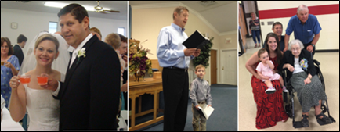

A good man was freed from a prison of clay on Tuesday.  How it was done and why it was done is not worthy of our concern.  What is worthy, is praise for a glorious and victorious Savior.  To understand the miracle which took place when Mike closed his eyes in death, only to immediately open them in Heaven’s immortal glory – is to understand the depth of love our Lord has for us.  It is the same miracle which took place in August of 2010, when Mike and Julie’s newborn son, took his heavenly flight.  The Lord has prepared them a place.  The same as He has prepared for us.  There is no pain, no fear and no end to the joys waiting for us.  Mike was blessed with incredible blessings during his life here – but the joys and sorrows are not worthy to be compared to the eternal perfection and full presence of his Savior Jesus Christ.  Mike knows the loved ones he has bid farewell to will be fine.  He knows they, in fact we all, will join him in the Lord’s presence.  There to forever be with the Lord, in perfect love and timeless, endless rejoicing.  God bless us to set our sights upon what He has done for us.  May God be praised for blessing us with the life of Bro. Mike Winchester.

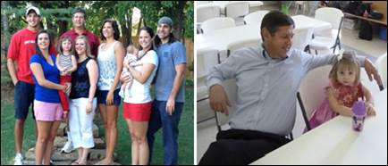

Please pray for Julie, Larry, Kathy, Carolyn, Brett, Becca, Stephen, Emily, Zach, James, Emily, Kate and John.  Pray too for their extended family, the Bethlehem Church and so many others who mourn in this loss.

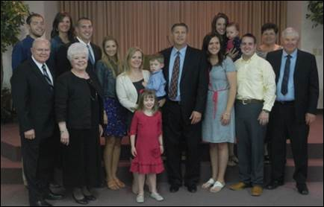

Obituary:

*- Bro. Michael Kevin Winchester age 52 of Washington, Oklahoma, went home to be with his Lord on Tuesday, November 15, 2016, in Oklahoma City. Michael was born October 19, 1964, in Phoenix, Arizona.  He was the oldest of three sons born to Larry and Kathy Winchester.  His family moved to Marietta, Oklahoma, when he was nine years old; there he graduated from high school in 1982. While in high school, Michael excelled in football, basketball, and track.  After high school, Michael attended the University of Oklahoma.  He was the punter and a four-year Sooner football letter-winner.  Michael was a member of the 1985 National Championship team.  He graduated from OU in 1986, with a degree in business and began his career of 30 years with Southwest Airlines in Oklahoma City.*

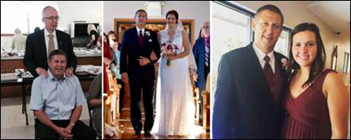

*Bro. Michael lived in Washington, Oklahoma, where he raised his children and was married to the love of his life, Sis. Julie (Johnson) Winchester. Together they committed countless hours supporting their children in their many activities.  Bro. Michael was a devoted husband, a dedicated father and grandfather, a loving son, brother, and uncle.  He was well respected by his coworkers and his community.  In 1982, he became a member of the Bethlehem Primitive Baptist Church in Purcell, Oklahoma, and was ordained as a deacon.  Bro. Michael’s faith was the foundation upon which he built his life. This was evident in his service to the Lord, the Church, and his family. The example he set will continue to benefit all those who loved him.*

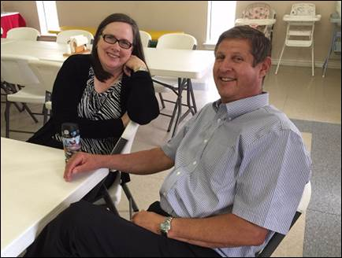

*He was preceded in death by: a son, Brian Jacob Winchester in 2010, His grandparents, Bro. W.A. Winchester, Bill and Amy Holmes Harvey and Sis. Marie Bass, Bro. J.C. Johnson and Sis. Sue Abshire.  One aunt, Doris Gammill; He is survived by: Wife, Sis. Julie Winchester - six children, Sis. Carolyn Baker and husband Brett of Norman, Oklahoma, Sis. Rebecca George and husband Stephen of Dallas, Texas, Bro. James Winchester and wife Sis. Emily of Kansas City, Kansas, Sis. Emilyne Winchester, John and Kate Winchester all of Washington, Oklahoma.  One grandchild, Leighton Baker of Norman, Oklahoma Parents, Bro. Larry and Sis. Kathy Winchester of Marietta, Oklahoma.  Two brothers, Greg Winchester and wife Danielle of Marietta, Oklahoma, David Winchester of Ardmore, Oklahoma.  Grandmother, Sis. Maude Winchester of Purcell, Oklahoma.  In-laws, Bro. Ron and Sis. Carolia Johnson of Aledo, Texas, Brother-in-law, Bro. Eric Johnson and wife Sis. Joyce of Buda, Texas.  Eight nieces and nephews, Courtney, Kelsi, Abbie, Megan and Tyler Winchester, Eva, Wyatt and Grace Johnson; As well as many other aunts, uncles, cousins, and a host of other relatives and friends.*

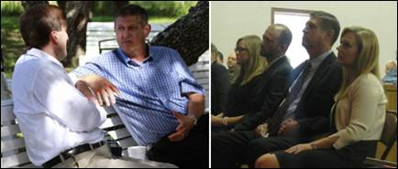

In lieu of flowers a memorial fund has been set up.  Please mail checks to:

**Michael Winchester Memorial Fund**

c/o Mr. Matthew A. Green

First United Bank 570 24th Ave NW

Norman, Oklahoma 73069

<https://www.gofundme.com/michaelwinchester>

**IMPORTANT** – in using the GoFundMe, be aware that there is second page that has been set up called “Winchester Family Memorial Fund”.  It was setup by a friend of the family, who was simply trying to help.  So please do not use it, but instead use the full URL that I have listed above.

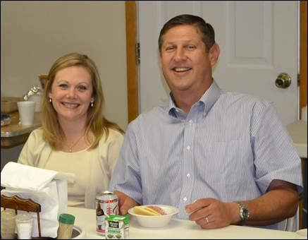

Pictured are Sis. Julie and Bro. Mike and the Winchester family.

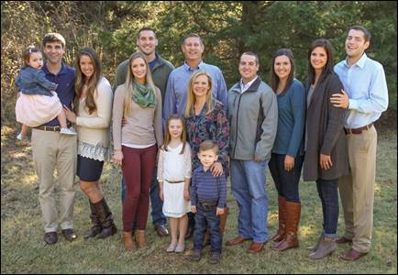

**Funeral Arrangements with Maps**

Family Visitation will be held from 6:00pm - 8:00pm on Friday night at the Wilson-Little Funeral Home.

Wilson-Little Funeral Home

127 S Canadian Ave

Purcell, Oklahoma 73080

<http://www.wilsonlittle.com/fh/home/home.cfm?&fh_id=14204>

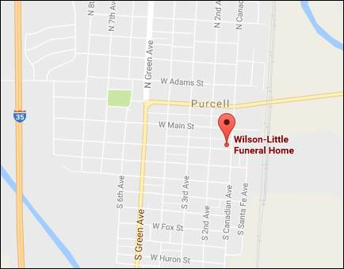

The Funeral Service will be held on Friday morning at 10:00am, in the First Baptist Church at Purcell, Oklahoma

First Baptist Church

400 W Main St

Purcell, Oklahoma 73080

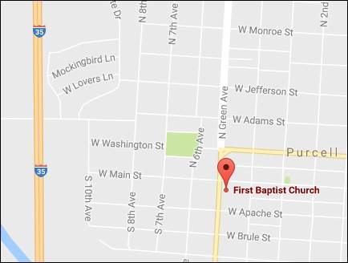

Interment will follow, at the Hillside Cemetery in Purcell, Oklahoma (73080)

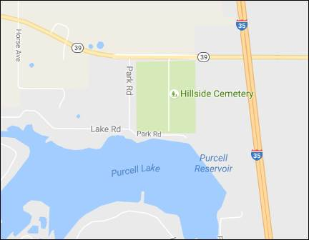

Lunch will be served afterwards at the Bethlehem Primitive Baptist Church in Purcell, Oklahoma.  The Bethlehem Primitive Baptist Church address is listed below:

16958 Horse Ave.

Purcell, Oklahoma 73080

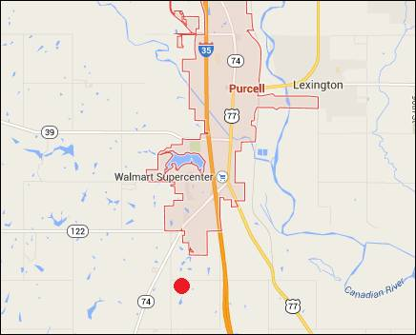

From I-35 take highway 74 west / south.  Turn left on Horse Avenue and continue south until you see the Church on the left.  It is just past 170th Street.

